Chapter 10, Problem 7.

Use nodal analysis to find V in the circuit of Fig. 10.56

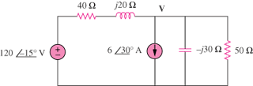

Figure 10.56
For Prob. 10.7.

